**Cucumber expressions not regular expressions**

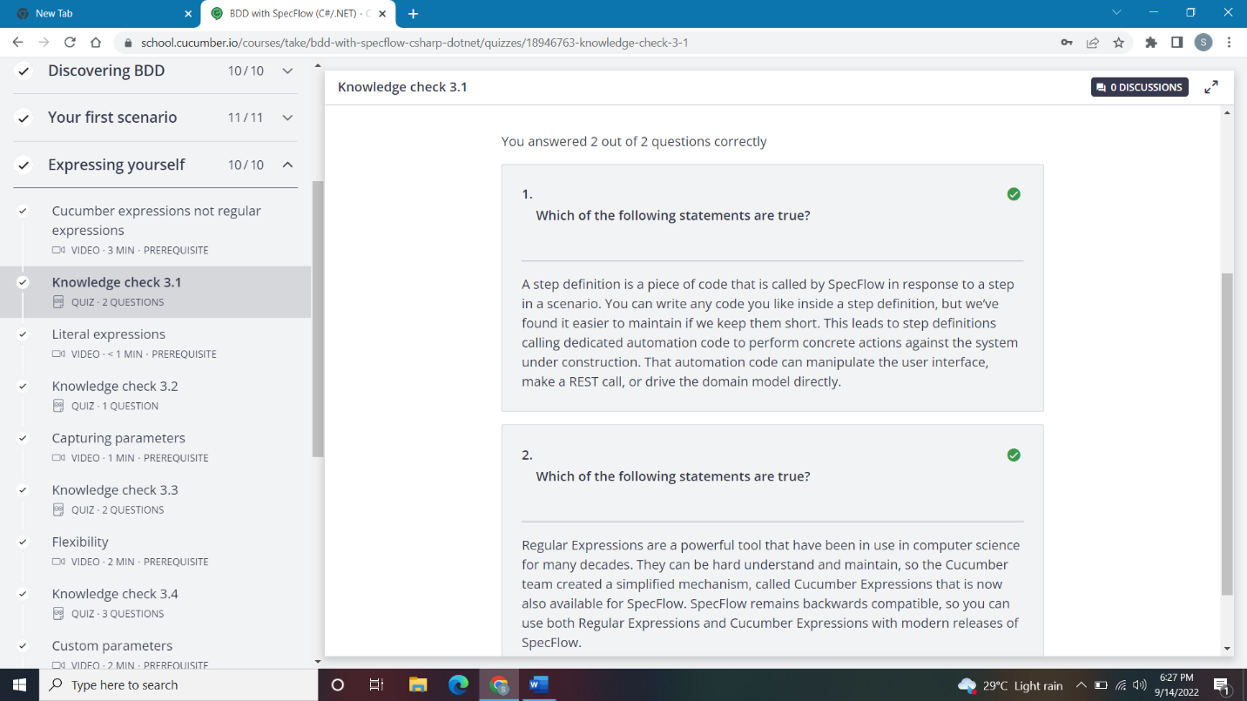

### Literal expressions

### Capturing parameters

### Flexibility

### Custom parameters

